8th VA COMP.
Common Assessment #1: Art History
Throughout time, artists have built upon each others' influence. An artist can view a work from the past and become inspired to build on ideas and develop a unique approach of his/her own. Select an artwork you have created so far in 8th VA COMP. Compare this artwork with an artist's artwork(s) from the past/present and answer the following questions:
1. Who is the influencing artist and why was/is their work impactful? (at least 3-5 sentences)
2. What is similar about your work and the artist's work? What is different?
(focus on style, media, subject matter, purpose and outside influences)
Style: the category of art (expressionism, abstract, non-objective, realism, fauvism, etc. etc.)
Media: the materials used to make the art (paint, clay, paper, etc. etc.)
Subject matter: The main characters/shapes/objects seen in an artwork.
Purpose: The reason the artist made the artwork/what the artist wants the viewer to learn/see/understand
Outside Influences: What made the artist want to make this artwork
3. Do you think this artist would have liked your work? Why or why not? (at least 2 sentences)
Choice #1
Compare and Contrast your non-objective, abstract tempera painting with the art of Vasily Kandinsky.
-Kandinsky was a Russian, abstract, non-objective artist who lived from 1866-1944.
Abstract art: art that is not based on realism
Non-objective art: an abstract style of art that does not represent any actual object; just shapes, colors, and lines
-Kandinsky painted what he heard. He turned sounds (non-visual) into shapes (visual).
-Kandinsky painted in oil paints.
-Kandinsky’s was influenced by his favorite sounds (Nutcracker Suite and Swan Lake by Tchaikovsky)
-Kandinsky liked to use bold colors and geometric shapes.
-You listened to Dance of the Cygnets from Swan Lake by Tchaikovsky while you made your artwork
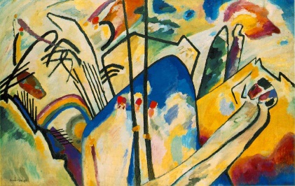 Kandinsky’s Composition IV, painted in 1911 (larger version on board)
___________ ___________ ___________ ___________ ___________ ___________ ___________
Choice #2
Compare and contrast your expressionist, fauvist tempera-resist artwork with the art of Marc Chagall.
Tempera-resist: an art method wherein the artist paints thick layers of tempera paint, coats the dry paint with
India ink, and then washes the dried ink off.
-Chagall was a Russian, Jewish, expressionist, surrealist artist who lived from 1887-1985.
Expressionism: an art form that deliberately abstracted real things so that the purpose of the artwork was for the
artist and/or the viewer to have an “emotional experience.”
Fauvism: (French for “the wild beasts”) a group of early 1900’s artists whose artwork emphasized painterly
qualities, strong color, and emotion over realism.
-Chagall was treated unfairly in Russia because he was Jewish. He moved to France as a young man for a better life.
-He painted images from his dreams and from his childhood. He used personal symbols to represent parts of his life. For example, cows always represented rural childhood in Russia.
-Jewish people often had to either had the fact they were Jewish, or celebrate their heritage. Chagall chose to celebrate
his religion and he was very proud to be Jewish.
-Chagall is known for his use of color. He wasn’t worried about realism and used bold, bright colors in his artwork.
-Chagall’s artwork was usually very personal; he painted about the things and people that were and had been important
in his life.
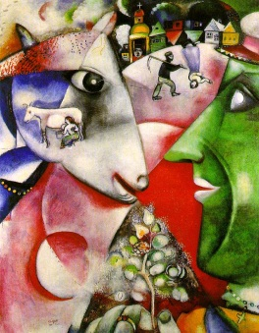

Chagall’s I and the Village, painted in 1911 (larger version on board)

